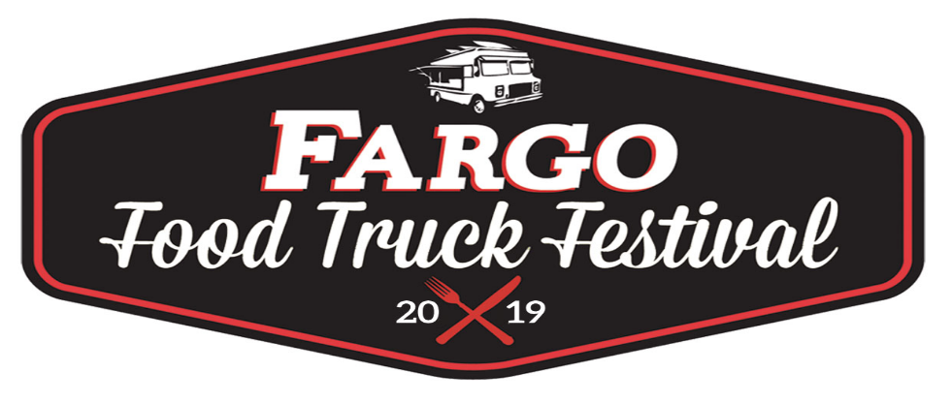

2019 Non-Food Vendor Application
The 5th annual Food Truck Festival will again be held this summer at the North Dakota Horse Park. We are looking for non-food vendors who will compliment our event. This year’s event dates are Fri. Aug. 16th- Sun. 18th from 11am-11pm Friday/Saturday & 11am-6pm Sunday. Vendors should be on site ready to sell by 11am Friday. We will try and accommodate any vendor who wishes to set up the night before. Again, we will utilize the North Dakota Horse Park as the unique backdrop for the event. We have tons of parking, open areas and many other aspects that will make our event special.
What are we looking for from you? Bring your mobile setup, your crew, and your “A” game. This festival is all about showcasing craft “eats” so we’ll look for the non-food vendors who impress with their mobile setup and unique products. Retail spaces are $300 for a 20ft x20ft location, (before July 5th) please consult us if your setup is outside of those dimensions. Of course, we’ll ask you to promote our event through any social marketing channels and other events that you are participating in this summer.
What we’ll provide: a ton of marketing (Printed marketing, radio, social etc.), the venue, security, liability insurance (incidental), plus entertainment.
We’d love to hear from you, and we are always open to any ideas that can make this event even more successful. We will make this an annual event and maybe even branch out to other cities in the area. Join us this year and get higher preference for future events.

Thanks for your consideration,

Michelle Schmitz-Bohrer
Event Organizer
msbmb@westriv.com
701-870-5994

Truck Name-

Contact name(s)-

Phone-

Email-

Website or social media page(s)-

Describe your business/what are your specialties?-

Can you provide us with high quality photos and or logos of your business setup and or products (for adding to posters, marketing efforts)- (Yes) (No)

- Email photos to mike@midwestsportstours.com

Please note that you will be on your own for power for this event. It takes a major logistical effort to power the food trucks for this event. Please describe to us how you will generate any power you may need. Feel free to reach out to us to discuss options.-

Dimension of your setup? L x W-

Please submit your top (8) product offerings. We will work with non-food partners to ensure that nothing is over duplicated.

1.) 2.) 3.) 4.)
5.) 6.) 7.) 8.)

- Proof of insurance with Midwest Sports Tours as additionally insured.

- A copy of ND tax permit

This year’s event is $300 for non-food vendors. Payments due along with completed registration. (Late registration add $25- make your registration by Friday July 5th to avoid late registration fee)

As promoters, the final thing we are asking for is (3) $10 “Gift certificates” redeemable per vendor to be used in our marketing. (On-air radio interviews, etc.) Gift certificates will be produced by the festival and only (3) will be produced for each participating truck.

We will be looking for special room rates at partnering hotel properties to make it a little easier for those of you who are traveling-

Please understand that submitting this application does not in any way guarantee you a spot in this year's event. Our selection committee considers many things including: Product offerings, marketability, our previous working relationship, and what you can provide to this year's event.

I understand that as a vendor, sales of water, soda and other drinks are not allowed. Specialty drinks, and drink related vendors will be approved by promoter. Water, soda and alcohol will be served by a licensed event partner.

Please make checks payable to: Midwest Sports Tours

Address: Michelle Schmitz-Bohrer, 418 5th Ave. NE, Hazen, ND 58545

Participating Non-Food Vendor Fargo Food Truck Festival Representative

Name_______________________ Name_______________________

Signature____________________ Signature____________________

Date________________________ Date________________________

